Lesson Overview
Logistic functions are used to describe growth in many real-world situations: animal population growth under limited resources, spread of a disease or a rumor through a community, or the cumulative sales of a new product. This activity is a simple introduction to the idea of logistic growth through an easily acted out simulation. | Learning Goals
Students will be able to:
1. Model a contextual situation mathematically and use the model to answer a question
2. Use data from a simulation to create a scatter plot, and describe how a variable changes over time
3. Determine and interpret a function modeling a quantitative variable over time

About the Lesson and Possible Course Connections:
The activity can be used with secondary school students with some basic familiarity with exponential growth and decay. The students should be familiar with using tables or scatterplots to identify trends and patterns. Students physically model the spread of a disease with the aid of a simulation easily carried out with a random number generator on a TI-Nspire. This activity could be used as a nice introduction to logistic growth and models.

CCSS Standards
Functions Standards:
- F.1F.A.1
- F.1F.A.2
- F.1F.B.4
- F.1F.C.7
- F.1F.C.8
Mathematical Practice Standards
- SMP.4

Lesson Materials
- Compatible TI Technologies:
TI-Nspire CX Handhelds, TI-Nspire Apps for iPad®, TI-Nspire Software
- Modeling Virus Spread_Teacher Notes
Background
With no constraints, quantities like populations of organisms will exhibit exponential growth (the more organisms there are, the more they reproduce). But realistically, resources like food are limited and the environment can only support a certain population capacity. Similarly, a virus (or a rumor) spreading through a community may spread quickly at first, but there is a maximal capacity (everyone has contracted the disease or heard the rumor) that forces the rate of spread to level off. This activity uses the spread of a virus to illustrate this phenomenon.

Students will create a table and a plot of the data and think about how an exponential function could be involved in creating a model for the spread of the virus. Rather than simply using the built-in regression functionality provided by the technology, students are asked to think about the features of a possible model and why they make sense in the context of the spread of the virus. Once they have a model, students are asked about how that model would change under different conditions or constraints.

Teacher Note: Students should open a new document and add a calculator page to generate random numbers and can track the spread of the virus on a lists & spreadsheet page.

Facilitating the Lesson
A leading question to set the scenario for simulation:
A person with a virus transfers it to one person a day, but once you have had the virus, you won’t get it again. If a class has 25 students, how long will it take before every student has had the virus?

A general approach is to simulate the spread of the virus through a population of 25 students by 1) labeling the students with the numbers from 1 to 25, and then 2) finding some method to indicate which students are infected with the disease each day, based on the number of students already infected. One nice approach to acting out the simulation with the entire class is to give each student a sticky note with a number, have all students stand and as that student’s number is generated, the student “gets the virus” and sits down.

1) Open-Ended Approach:
Ask students how they might simulate the situation. A possible answer is to use two decks of cards with 25 identical cards pulled from each deck. The cards in one set would be given to students. The other set would be shuffled and a random card drawn from the deck to identify the person infected. Note that some organized method such as in Figure 2 and Table 1 is necessary to keep track. Students could keep track of the students with the virus (those sitting down) on the board or in their notebook so they can be sure not to count someone twice. Another approach would be to use a random number generator as described below.

2) More-Structured Approach to Finding a Model:
Use a random number generator to generate random numbers as described below. The simulation can easily be adjusted for different class sizes. If this is the first time students have simulated a situation, be sure they understand the syntax for generating random numbers (the minimum value, the maximum value and how many random numbers they want to generate). It is important to keep track of the days, the number of the student who was infected that day and the cumulative number of infected students over the days. Continue the simulation until every student has been infected with the disease.

With 25 students standing, generate one random number between 1 and 25 on day 0 to identify the student with the virus and another random number between 1 and 25 on day 1 to generate the number of the person that was infected by the first person (Figure 1, Row 1). When a student is infected with the disease (her number is randomly generated), that person sits down. In Figure 1, on day 0, one student was infected, student #1. Generating another random number, student #1 infected student #5 so on Day 1, a cumulative total of two students have been infected (Figure 2, Row 2 in Column B), students #1 and #5. Since two students have been infected, now generate 2 random numbers (one for each student) to see whom they infect. (Figure 1, Row 3). | 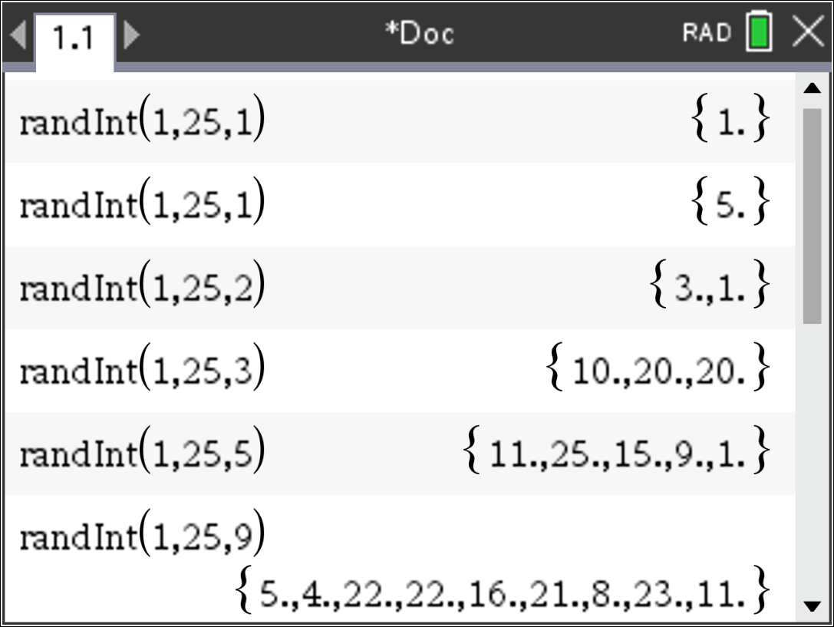  Figure 1. Students Infected each day
On Day 2 (remember each infected person infects a new person each day), only one new student is infected because student #1 was the initial student with the virus. At the end of day 2, a cumulative total of three students have been infected. A complete simulation is displayed in Table 1 below. Be sure students articulate what the random numbers being generated each time represent and can interpret the numbers in terms of students being infected with the disease. | 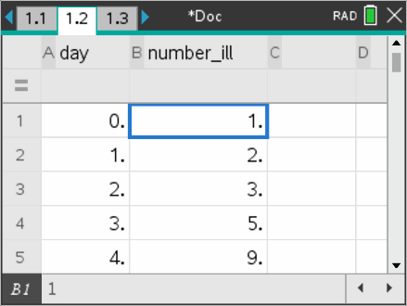  Figure 2. Tally of day and cumulative number of infected students

Table 1

Day (Student #s Generated) | Total Number infected
0 (1) | 1
1 (5) new: 5 | 2
2 (3, 1) new: 1 | 3
3 (10, 20, 20) new: 10, 20 | 5
4 (11, 25, 15, 9, 1) new: 11, 25, 15, 9 | 9
5 (5, 4, 22, 22, 16, 21, 8, 23, 11) new: 4, 22, 16, 21, 8, 23 | 15
6 (7, 19, 7, 3, 19, 6, 15, 21, 23, 11, 3, 11, 19, 10)  new: 7, 19, 6 | 18
7 (25, 8, 13, 11, 6, 3, 25, 6, 4, 24, 10, 13, 6, 14, 7, 19, 8, 14)  new: 13, 24, 14 | 21
8 (3, 12, 7, 24, 14, 7, 21, 7, 22, 19, 1, 22, 9, 6, 21, 4, 1, 25, 3, 11, 20)  new: 12 | 22
9 (9, 10, 7, 15, 14, 7, 18, 11, 13, 5, 7, 10, 2, 22, 23, 18, 8, 7, 17, 18, 8, 10)  new: 2, 18 | 24
10 (8, 11, 17, 12, 14, 5, 12, 24, 18, 23, 3, 20, 9, 15, 2, 23, 25, 5, 7, 19, 24, 17, 24)  new: 17 | 25

Ask students….
- At the end of the simulation ask students what do they notice? What do they wonder about?
- Can they find an algebraic model to describe what they found? What would be important to think about in creating such a model?

Students might graph the data in their spreadsheet and look for a pattern. (Do not allow them to use any of the regressions available on their calculator. The key idea here is that students reason about the situation and the data and try to generate their own model rather than resorting to a “black box”.) Encourage them to experiment with different functions using Menu, Analyze, Plot function with different students trying different expressions for f1, the function relating the time and the number of students with the virus.

Student Instructions: In your groups,
- Exchange your ideas.
- Decide as a group how you will begin to analyze the data. Give each member of the group a job to do that will help you in the work.
- Decide whether your approach seems reasonable for the data. Explain why you think the model you found is appropriate. What are the drawbacks, if any, to your model?

What to Expect: Example Student Approaches
- Possible student discussions might include some efforts to visually fit familiar function graphs to the scatter plot.  - For example, students might look at the early behavior of the data and think that a quadratic (parabolic graph) function might provide a fit:  - “Let’s try squaring – oops way off (Figure 3). | 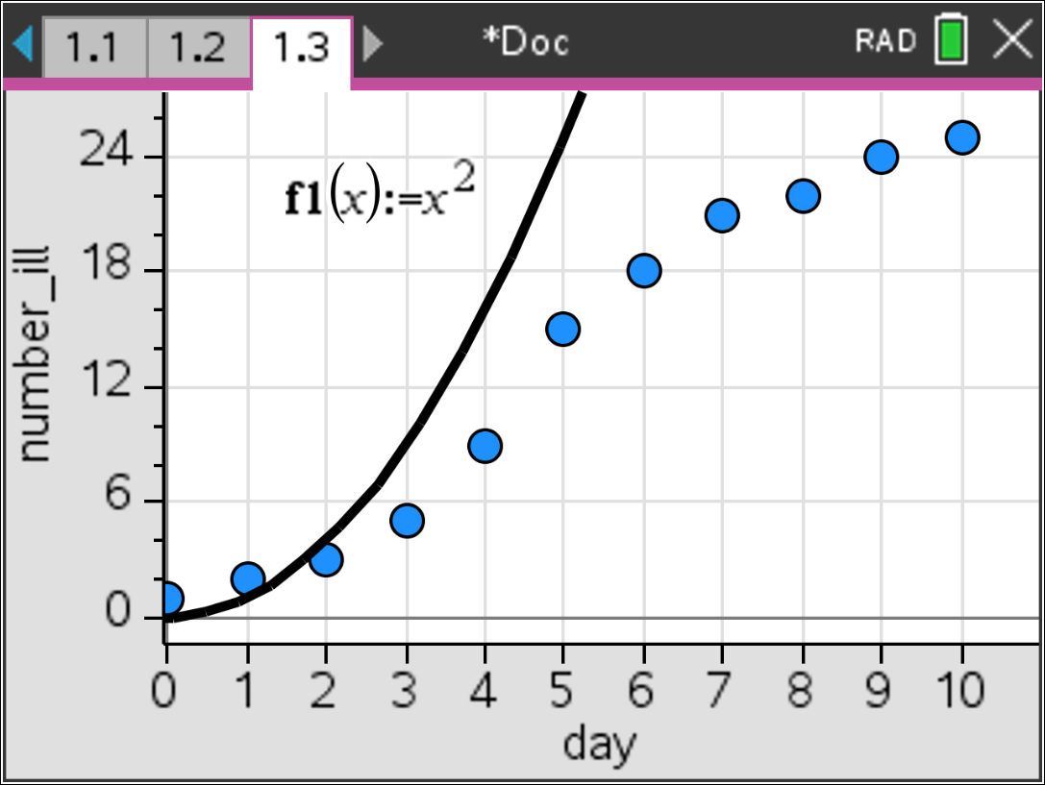  Figure 3. A quadratic model
- Even if we slow down the growth using a coefficient of 0.5 (Figure 4) so the expression works for the first few days, squaring keeps getting bigger and bigger numbers, and the number seems to slow down after day 7 when only a few kids are left to catch the virus.” | 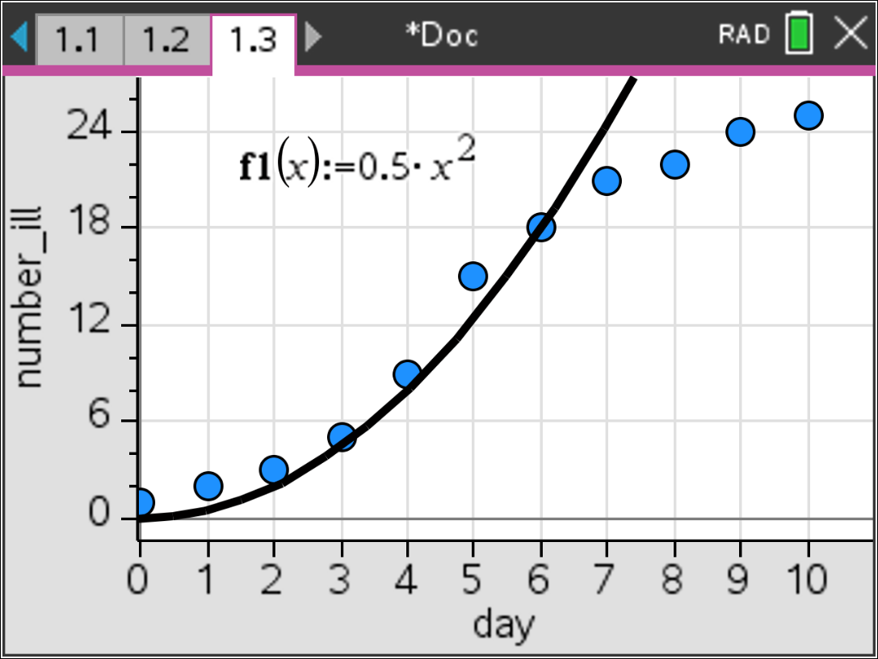  Figure 4. Adjusting a quadratic model
  - Similarly, students might consider an exponential growth curve, but encounter the same difficulty with the growth rate slowing and leveling off.
  - If students don’t think of dividing, the teacher might suggest something like: “
    - We know what has to happen at the beginning (the number with the virus is 1) and at the end (the number with the virus is 25, the whole class). What kind of expression might let this happen and how could it help us in trying to find a model?” “Maybe we should try dividing and see what happens. The 25 probably has something to do with the rule… lets divide 25 by something...”
    - “That something we divide by should be 25 on day one and close to 1 on
day 9.”
    - “At the beginning it looks like the number is doubling so perhaps 2^{x} plays in somehow.”

After discussion, unless the students have moved in the right direction, the teacher should suggest that students consider a function expression where x represents the day number and f1(x) the total number of infected people:  f1(x) = 25/(1+24(2^{-x})) = 25/(1 + 24(1/2) ^{x} )  and its characteristics. The 1+24 gets at the division by 25 when x is 0 and the 2^-x gets at the doubling but needing to decrease in value. Note that f1(0) = 1 (the first infected student), and as x increases, the value f1(x) will approach 25/(1+0) = 25 (so the whole class eventually has the virus).  And importantly, the graph of the function has a shape that fits the data fairly well (Figure 5).  After students have a model, have them think about the following questions:  - It looks like the number who get the virus in a day peaks around day 5 - is this always the case? How is that visible in the graph?  - What could we learn by taking successive differences in the next column of the spreadsheet? and successive differences of those differences? | 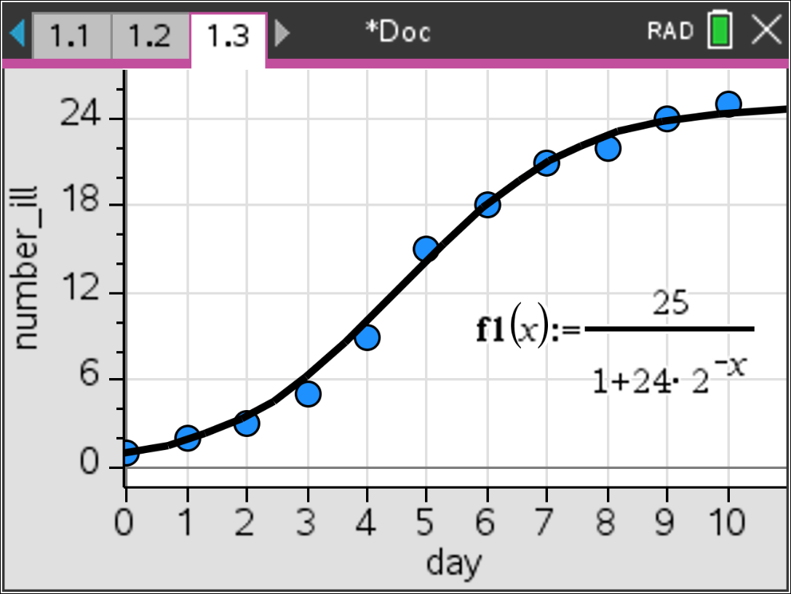  Figure 5. Estimated model involving division and exponential function
Teacher Note: The situation can be modeled by a logistic curve (Figure 6), but it is not necessary for students to formalize the relationship as logistic. | 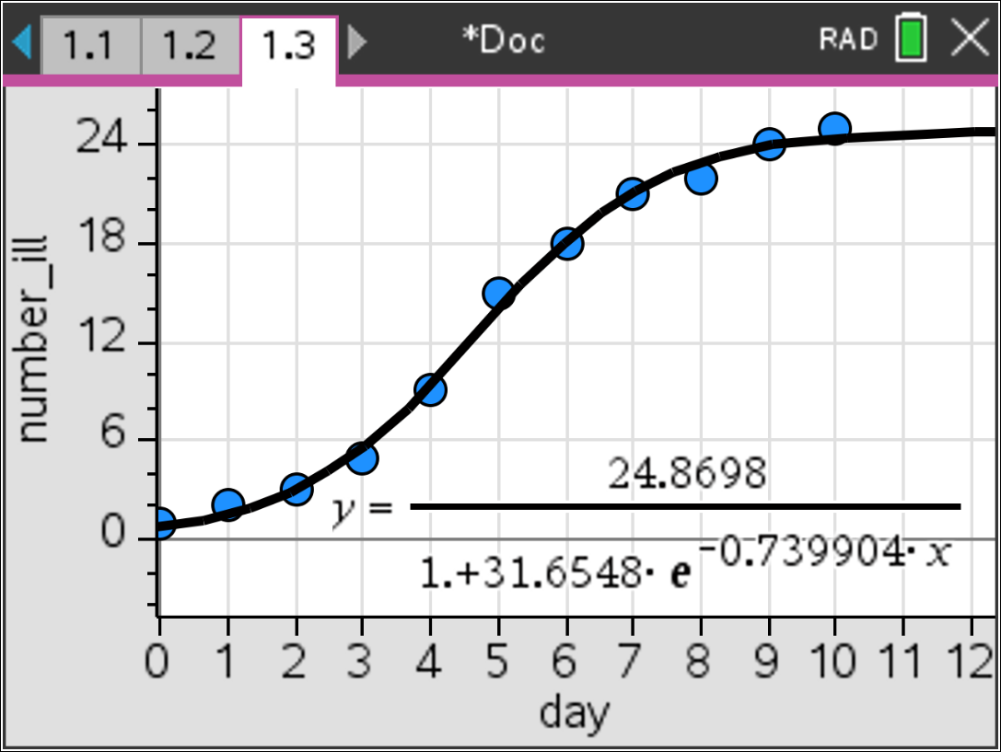  Figure 6. Logistic Curve fit.

Validating the Models
Students should validate their models either by asking whether the models make sense in different scenarios related to the context or by finding other information to reflect against the model. The suggestions below might be useful in helping students think about whether their model was reasonable:
Students should try to simulate the spread of the virus for classes of different sizes to see if the same pattern holds or to get a better idea of the relationship between the days and the number with the virus. They might check to see if a model they find fits the new data and the context. The key idea is not to get a “right” answer but to find a model that is not too unreasonable and that makes sense in the context. Students should share their work and thinking with each other, critiquing the models and offering suggestions.
Extension

- Have students pose “what if” scenarios. What if the class size was 40? 20? What if each student infected two students? How would you expect the data to change? The plot? The model?
- After students have worked through the problem and discussed possible solutions, they might be introduced to the idea of logistic regression (see Figure 6).
Check out logistic functions http://www.foresightguide.com/logistic-growth-s-curves/ to see where they are used and https://en.wikipedia.org/wiki/Generalised_logistic_function for the mathematics

- A Problem: Preventing an Epidemic
A person infected by a virus arrives in a population of 100,000. This disease can transmit the virus to 1.75% of the susceptible population following contact with people have the virus and who retain the capacity to infect others with the virus for one week. Those who are no longer infectious (recovered) and will not get the virus again. You are responsible for the public health of this population, and thus wish to encourage vaccination in anticipation of the epidemic. The best estimate of the health officials is that an average person in this population makes contact with 60 people per week.

- Simulate weekly changes in the number of infected people if no action is taken.

- Because of side effects and the cost, it is not practical to vaccinate the whole population. Determine what percentage of the 100,000 population should be vaccinated to prevent an epidemic.
Resources:
Adapted from Nishimura, K., Kobayashi, R., & Ohta, S. (2018). Lesson Study at Upper Secondary Level in Japan: Potential and Issues. Educational Designer Journal of the International Society for Design and Development in Education
Retrieved from: http://www.educationaldesigner.org/ed/volume3/issue11/article44/

