In this activity, students will use the unit circle to examine patterns in the six trigonometric functions. With the aid of the handheld and the file Trig Patterns.tns, students will compare angles created with the x-axis in all four quadrants and discuss with one another what is happening at each coordinate as they move the point around the circle. | 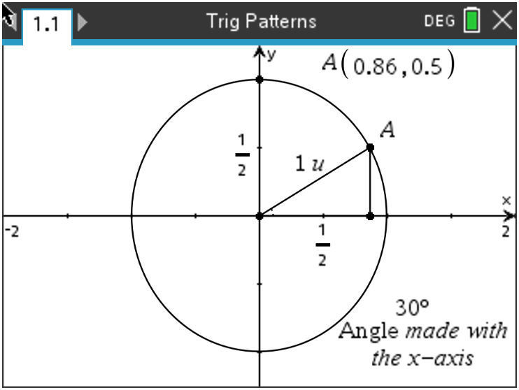

______________________________________________________________________________

Problem 1 – Searching for Patterns
Using the unit circle, the trig functions can be defined as follows:
$\sin{θ= \frac{y}{h}}$ $\cos{θ= \frac{x}{h}}$ $\tan{θ= \frac{y}{x}}$

Using the Trig Patterns.tns file, grab point A on the unit circle in the first quadrant by pressing and holding down on the center of the touch pad or by pressing ctrl then the center of the touchpad. Record the value for $\sin{θ,\cos{θ} and\tan{θ}}$ using the displayed x- and y-values, and the equations above.  Use the radian conversion to fill in the second column: $θ∙\frac{π}{180°}$ | 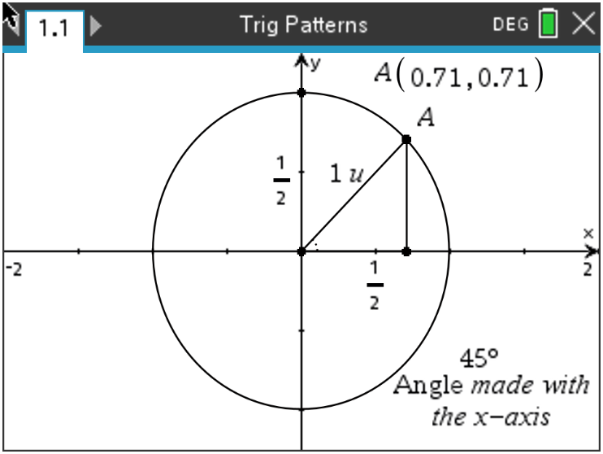

Problem 1 – Complete the Table
$$θ$$ | $$Radian Measure$$ | $$\sin{θ}$$ | $$\cos{θ}$$ | $$\tan{θ}$$
0°
30°
45°
60°
90°
120°
135°
150°
180°
210°
225°
240°
270°
300°
315°
330°
360°

Problem 2 – Searching for Patterns

Use the values in the table to respond to the following questions.

1. Find the values of $θ$ where $\sin{θ}$ is positive.

2. Find the values of $θ$ where $\cos{θ}$ is negative.

3. Find the values of $θ$ where $\tan{θ}$ is positive. Find the values of $θ$ where $\tan{θ}$ is negative. Explain.

4. Find the angle $θ$ where $\cos{θ}=\cos{30°}$.

5. Name two other pairs of angles where the cosine of the angle is the same.

6. Find the angle $θ$ where $\tan{θ}=\tan{45°}$.

7. Name two other pairs of angles where the tangent of the angle is the same.

8. Record all the patterns you see with the sine function.

9. Describe any other patterns you see.

10. Describe what happens at $0°, 90°, 180°, 270°, and 360° .$

11. Explain why the tangent function is undefined for some angle measures.

Problem 3 – Patterns in Reciprocal Functions

Using the unit circle, the reciprocal trig functions can be defined as follows:
$\csc{θ= \frac{h}{y}}$ $\sec{θ= \frac{h}{x}}$ $\cot{θ= \frac{x}{y}}$
Complete the following table by finding the reciprocals from the computed values on the first table.

$$θ$$ | $$\csc{θ}$$ | $$\sec{θ}$$ | $$\cot{θ}$$
0°
30°
45°
60°
90°
120°
135°
150°
180°
210°
225°
240°
270°
300°
315°
330°
360°

Use the values in the table to respond to the following questions.

1. Record any patterns that you see.

2. Discuss with a classmate if you notice if any of the functions are undefined. Find which functions and for what values of $θ$ they are undefined.

Further IB Application

In this application, students should use one of the following trig identities and the information used in the previous three problems to answer the questions (a) and (b):

$$\cos{2θ= \cos^{2}θ- \sin^{2}θ= {2cos}^{2}θ-1=1- {2sin}^{2}θ}$$

(a) Show that the equation $\cos{2θ}=\cos{θ}$ can be written in the form
$2\cos^{2}θ-\cos{θ}-1=0$.

(b) Hence, solve $\cos{2θ}=\cos{θ}$ where $0 ≤ θ ≤ π$.

