Topic 4: Statistics and Probability | Box Plots and HIstograms
- The cumulative frequency graph shows the amount of time in minutes, 100 people wait in line for tickets to the local theater.
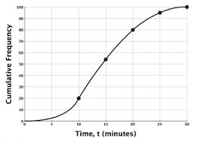
- Write down the median waiting time.  - Find the interquartile range for the waiting time.  - Draw a box and whisker plot on the grid below to represent this information.  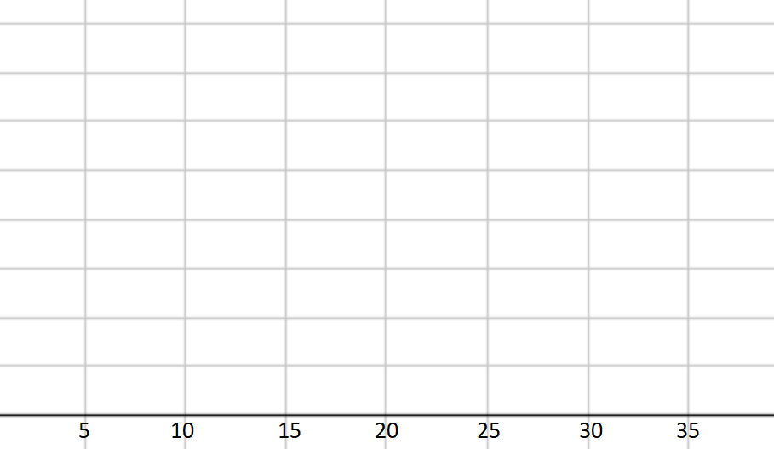  Mark scheme:  - 14 min (+/- 1 min)  - $18-12$  $$=6$$  - 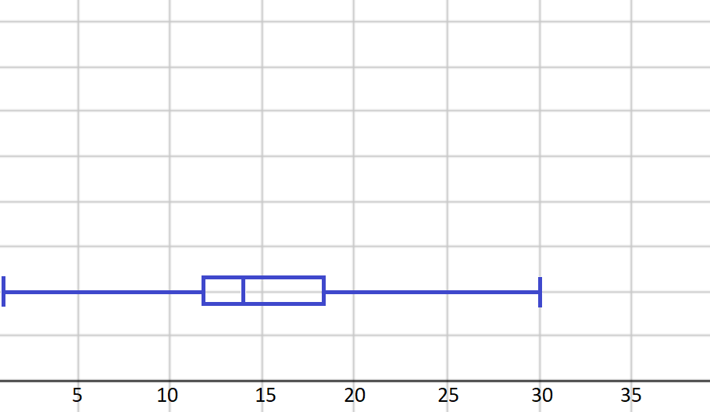 |  | (1 mark)  (2 marks)  (3 marks)  (A1)  (A1)  (A1)  (A1) for the endpoints at 0 and 30  (A1) for the ends of the box at 12 and 18  (A1) for the correct median of 14

