Math Objectives  - Students will explore the relationship between normal distributions and probabilities. They will examine these relationships graphically and algebraically.  - Students will be asked to use their handhelds to create normal distribution curves to help in their exploration and discussions.  - Students will try to make a connection with how to understand these topics in IB Mathematics courses and on their final assessments.  Vocabulary  - Bell Curve • Standardization • z-score  About the Lesson  - This lesson is aligning with the curriculum of IB Mathematics Applications and Interpretations and IB Mathematics Approaches and Analysis SL/HL  - This falls under the IB Mathematics Core Content Topic 4 Statistics and Probability:  4.9: (a) Normal distribution and curve.  (b) Properties of the normal distribution.  (c) Diagrammatic representation.  (d) Normal probability calculations.  (e) Inverse normal calculations.  As a result, students will:  - Apply this information to real world situations.  TI-Nspire™ Navigator™  - Transfer a File.  - Use Class Capture to examine patterns that emerge.  - Use Live Presenter to demonstrate.  - Use Teacher Edition computer software to review student documents.  - Use Quick Poll to assess students’ understanding  Activity Materials  Compatible TI Technologies: TI-Nspire™ CX Handhelds,  TI-Nspire™ Apps for iPad®, TI-Nspire™ Software | 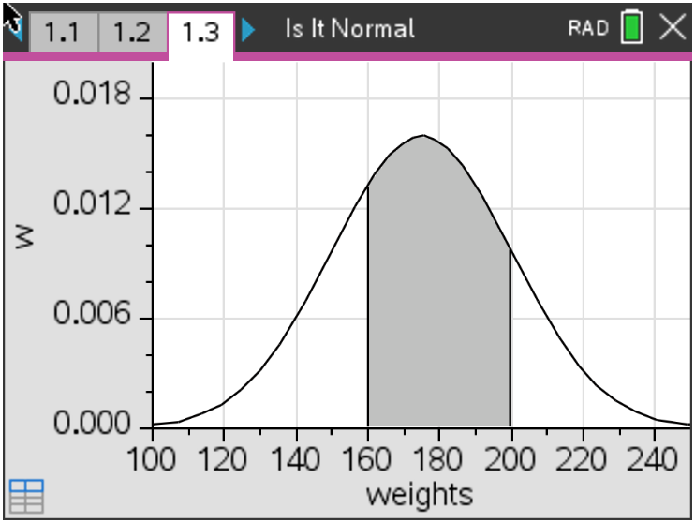  Tech Tips:  - This activity includes screen captures taken from the TI-Nspire CX II handheld. It is also appropriate for use with the TI-Nspire family of products including TI-Nspire software and TI-Nspire App. Slight variations to these directions may be required if using other technologies besides the handheld.  - Watch for additional Tech Tips throughout the activity for the specific technology you are using.  - Access free tutorials at http://education.ti.com/calculators/pd/US/Online-Learning/Tutorials  Lesson Files:  Student Activity  Nspire-IsItNormal-Student.pdf  Nspire-IsItNormal-Student.doc
______________________________________________________________________________
In this activity, you will use the idea of a normal distribution to pull together multiple areas of probability and statistics. You will start with basic ideas using means, standard deviations, quartiles, interquartile ranges, and z-scores, then progressing to conditional probabilities.

A normal distribution is a probability distribution that is symmetric about the mean, showing that data near the mean are more frequent in occurrence than data far from the mean. In graphical form, the normal distribution appears as a “bell curve”.  Data is symmetrically distributed with no skew, see the graph to the right. There are three rules to remember about a normal distribution:  1. Symmetrical Bell Shape  2. Mean = Median, both are located at the center of the distribution  3. 68% of the data falls within one standard deviation of the mean. | 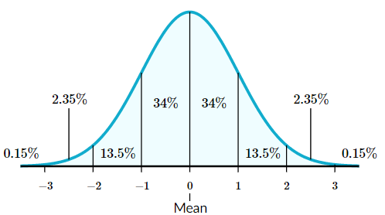

Problem 1 - Basics
Before we apply the idea of normal distribution to real world scenarios, let us recall what we have learned with some practice.
Using the data: 1, 2, 2, 3, 3, 3, 3, 4, 4, 4, 4, 4, 5, 5, 5, 5, 6, 6, 7
1. Find its mean and standard deviation.

Solution: mean = 4, $σ$ = 1.48678… $≈$ 1.49

2. Find Q₁, Median, Q₃, and the Interquartile Range.

Solution: Q₁ = 3, Median = 4, IQR = 5 – 3 = 2

3. Discuss with a classmate if you think this is a normal distribution. Explain. If you think it is, graph this normal distribution on your handheld.

Solution: The data is symmetrical and the median = mean.

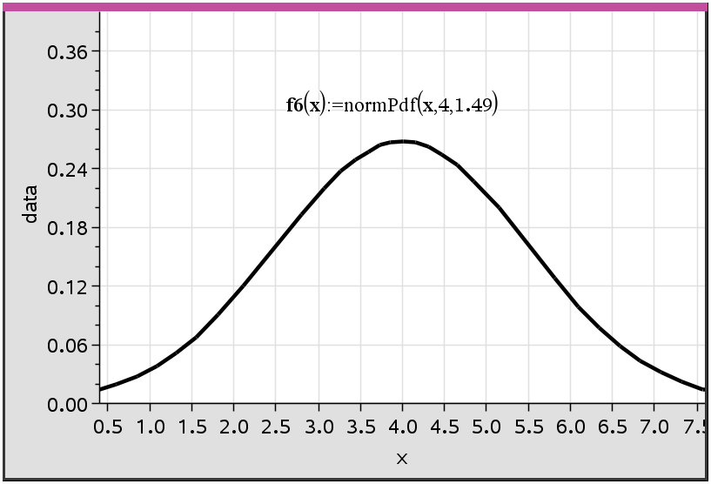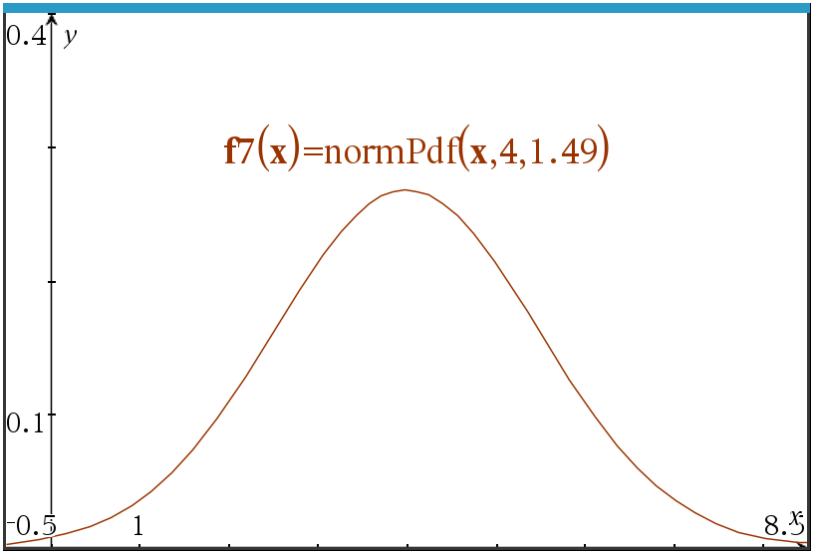

Tech Tip: This would be a perfect time to show your students how to graph the normal distribution curve using Normal Pdf on the handheld. Students can graph this by plotting a function on a data and statistics page after entering their data in a list or they can graph it on a graphs page using the normPdf function. Students would type normpdf(x,mean,standard deviation) as the function. Both methods require you to adjust the window settings accordingly.

When a normal distribution occurs, you can center your data around the actual mean, but if the full data is not given, and only its statistics, you can standardize your data to z-scores and center the data around the mean of 0 and standard deviation of 1.  To find the z-score, you will use the formula:  $$z= \frac{x- μ}{σ}$$  Where $x$ is the given data value, $μ$ is the mean, and $σ$is the standard deviation. | 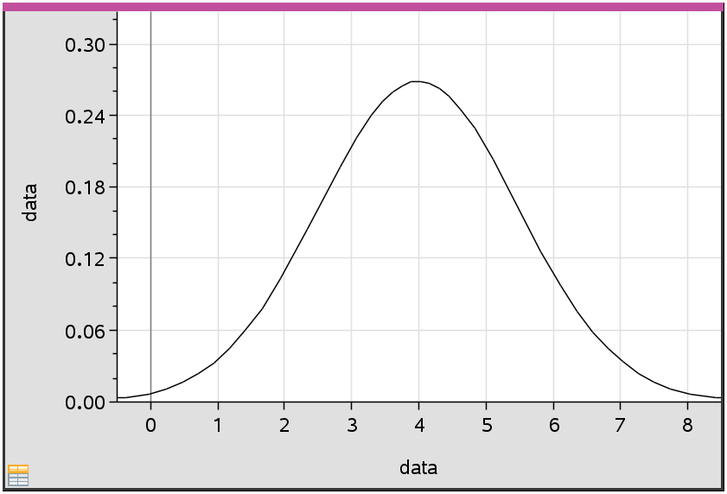  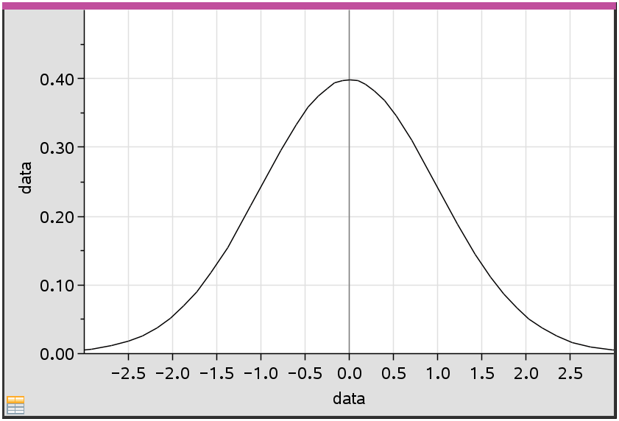

4. Convert $x=7$ to a z-score.

Solution: $z= \frac{7-4}{1.49}=2.01$

5. Given the z-score of 1, find its corresponding data value $x$.

Solution: $1= \frac{x-4}{1.49}$, $x=5.49$

These normal distributions can also be used to find probabilities. The cumulative probability of an event occurring is 100% or 1. The total area or shading under a normal distribution curve is also represented by 100% or 1. The shading can be broken down into individual probabilities. Using your handheld, you can find these probabilities by pressing menu, 5 Probability, 5 Distributions, 2 Normal CDF and fill in the boxes with the appropriate information for your cumulative probabilities.

6. Find the probability of selecting a piece of data that is greater than 5. This can also be written as $P(X>5)$.  Solution: From a calculator page press Menu,  5 Probability, 5 Distribution, 2 Normal Cdf  normCdf(5,∞,4,1.49) = 0.251  7. With a classmate, write the problem in question number 6 using z-scores, then find this probability.  Solution: $z= \frac{5-4}{1.49}=0.671$  $P\left(z>0.671\right)=normCdf\left(0.671,∞,0,1\right)=0.251$ | 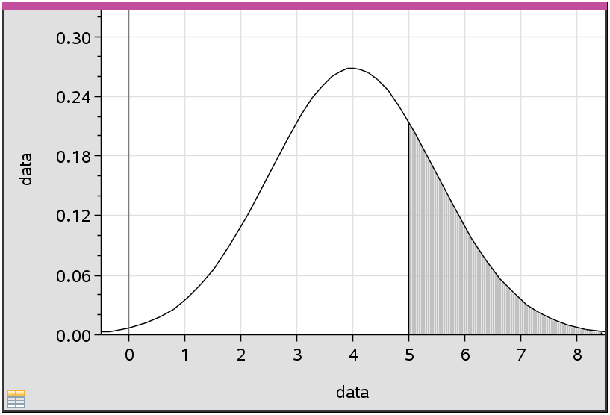  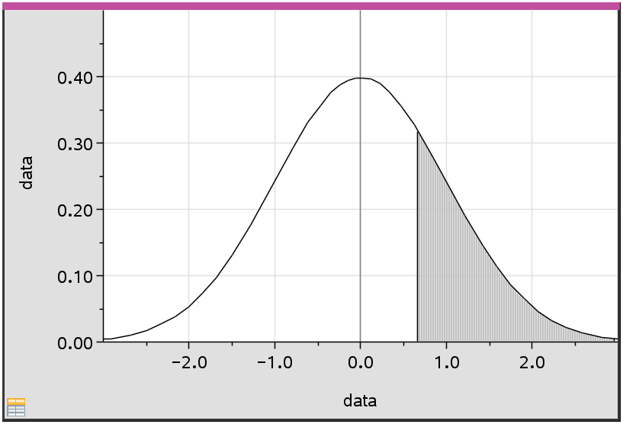

8. Find the probability of selecting a piece of data that is between the values of 2 and 5. This can also be written as $P(2<X<5)$.  Solution: normCdf(2,5,4,1.49)  9. With a classmate, write the problem in question number 8 using z-scores, then find its probability.  Solution: x = 5 becomes z = 0.671  x = 2 becomes z = $\frac{2-4}{1.49}$ = -1.34  P(0.671 < z < -1.34) = 0.659 | 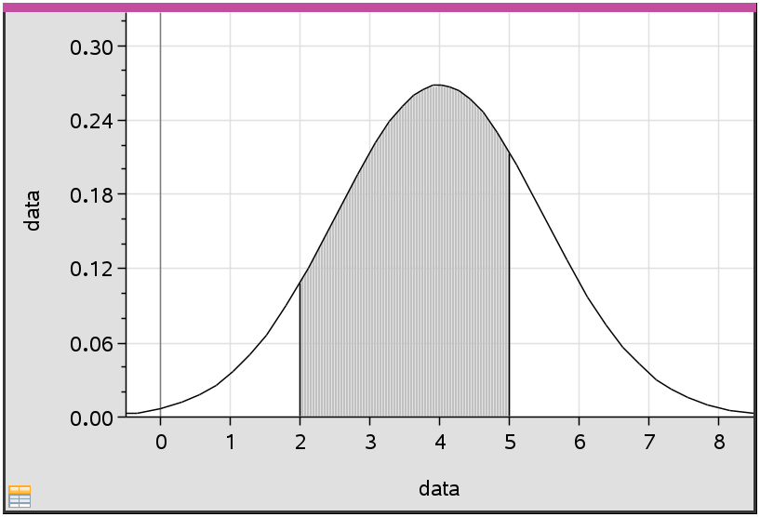  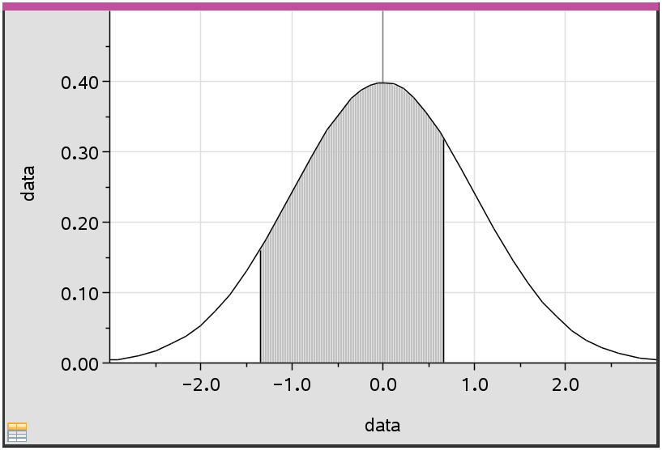

10. (i) Find $P(X<2.5)$. Sketch the normal distribution curve and shade the region under the curve
that represents this probability.

Solution: normCdf(-∞, 2.5, 4, 1.49) = 0.157

(ii) With a classmate, write the problem in part (i) using z-scores, find its probability and sketch the
normal distribution curve and shade the region under the curve that represents this probability.
Solution: $z= \frac{2.5-4}{1.49}= -1.0067$ P(z < -1.0067) = normCdf(-∞, -1.0067,0,1) = 0.157
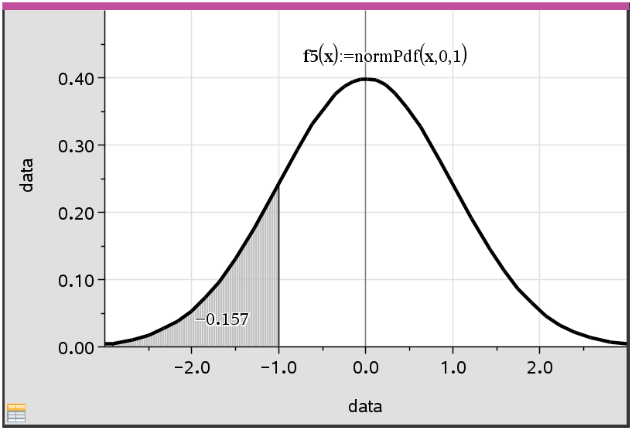

Problem 2 – Using Statistics and Probability to Find the Data
What if you were given the probability of certain data being selected, could you find individual pieces of this data?

Notation to be familiar with:
Normal Distribution centered around the mean of the given data: $X \sim N(μ, σ^{2})$
where $μ$ = mean, $σ^{2}$ = variance
Normal Distribution standardized around the mean score of 0: $Z \sim N(0, 1)$
where 0 = mean and 1 = variance

1. Given $Z \sim N(0, 1)$, find $a$ when $P\left(Z<a\right)=0.576$.
**Handheld tip: You will use the inverse Normal function by pressing menu, 5 Probability,
5 Distributions, 3 Inverse Normal, then fill in the Area box with the percentage of the area
shaded to the left of the $a$ value you are looking for.

Solution: z = invNorm(0.576,0,1) = 0.197

2. Find $a$ such that:  (i) $P\left(Z>a\right)=0.261$  Solution: z = invNorm(1 – 0.261,0,1) = 0.640  (ii) $P\left(-1<Z<a\right)=0.372$  Solution: P(z < a) – P(z < -1) = 0.372  P(z < a) – 0.158655 = 0.372  P(z < a) = 0.530655  a = invNorm(0.530655,0,1) = 0.0769 | 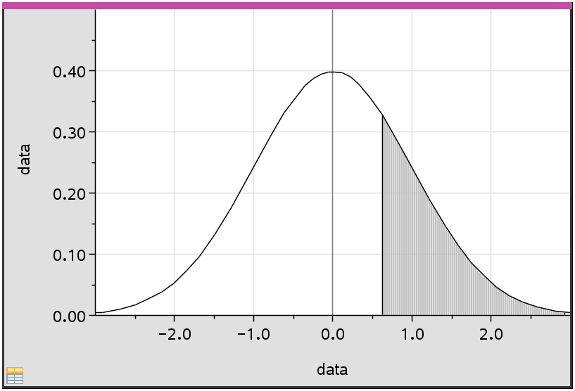  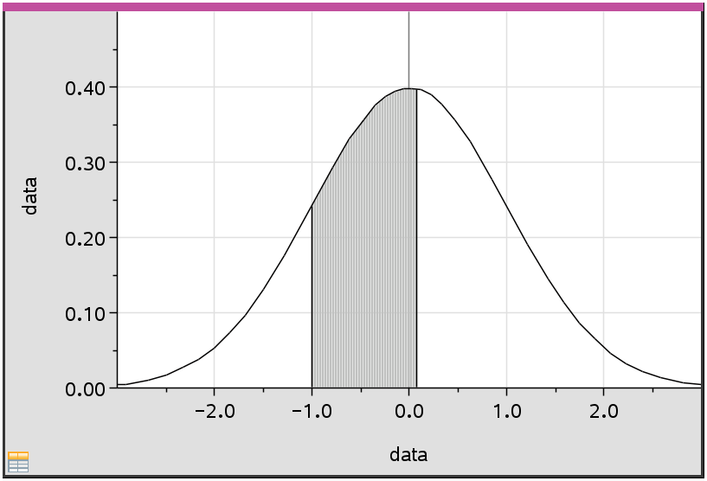

What if the raw data is not given, but the statistics of the data are, could you find individual pieces of data?

3. Given a set of data with a mean of 29 and a standard deviation 2.32, $X \sim N(29, {2.32}^{2})$, find the Interquartile Range of the data.
Solution: Find data values at both the 75th percentile and 25th percentile.
75th: invNorm(0.75,29,2.32) = 30.5648
25th: invNorm(0.25,29,2.32) = 27.435
IQR: 30.5648 – 27.435 = 3.13

Problem 3 – Real World Scenarios
1. The weights of oranges sold at a grocers are normally distributed with a mean weight of 175 g and a standard deviation of 25 g.
(a) If an orange is chosen at random, find the probability that its weight lies between 160 g and
190 g.
Solution: $X \sim N(175,{25}^{2})$
P(160 < x < 190) = normCdf(160,190,175,25) = 0.451

(b) Find the weight exceeded by 15% of the oranges.
Solution: P(x > a) = 0.15
a = invNorm(0.85,175,25) = 200.911 g

2. The grades of 400 students in an examination are normally distributed with a mean of 60 and a standard deviation of 10.
(a) If 7% of the students obtain a grade of $w$ marks or more, find the value of $w$.

Solution: $X \sim N(60,{10}^{2})$
invNorm(0.93,60,10) = 74.7579 ≈ 75

(b) If 15% of the students fail by getting $f$ or less, find the value of $f$.

Solution: invNorm(0.15,60,10) = 49.6366 ≈ 50

Further IB Application

1. A company manufactures fan blades for ceiling fans. The lengths of the blades, $L$ cm, are normally distributed with a mean 65 and a standard deviation of $σ$. The interquartile range is 7. Find the value of $σ$.

Solution: $X \sim N(65,σ^{2})$
$\frac{1}{2}IQR= \frac{1}{2}\left(7\right)=3.5$, therefore Q₁ = 65 – 3.5 = 61.5 and Q₃ = 65 + 3.5 = 68.5
75th percentile: invNorm(.75,0,1) = 0.674
25th percentile: invNorm(.25,0,1) = -0.674
$z= \frac{68.5-65}{σ}=0.674 or -0.674= \frac{61.5-65}{σ}$
$σ=5.1928… ≈5.19$

2. A bakery makes two flavors of cupcakes: Red Velvet and Vanilla.

(a) The weights, $R$ grams, of the red velvet cupcakes are normally distributed with a mean of 24 g and standard deviation of 1.6 g. Find the probability that a randomly selected red velvet cupcake weighs less than 21 g.
Solution: $X \sim N(24,{1.6}^{2})$
P(x < 21) = normCdf(-∞,21,24,1.6) = 0.0304

(b) The weights, $V$ grams, of the vanilla cupcakes are normally distributed with a mean of 22 g and standard deviation of 1.4 g.
Each day 65% of the cupcakes made are vanilla.
On a particular day, a cupcake is randomly selected from all those made at the baker.
(i) Find the probability that the randomly selected cupcake weighs less than 21 g.
Solution:
P(red velvet) × P(weight of RV < 21| red velvet) + P(vanilla) × P(weight of vanilla < 21|vanilla)
= (0.35) × (0.0304) + (0.65) × (0.2375)
= 0.165

(ii) Given that a randomly selected cupcake weighs less than 21 g, find the probability that it is red
velvet.

Solution: $P\left(red velvet | cupcake<21\right)= \frac{0.35 ×0.0304}{0.165015}=0.0644789… ≈0.0645$

Teacher Tip: This second Further IB Application deals with conditional probabilities and it would be wise for the students to know how to do these before attempting this problem.

Teacher Tip: Throughout this activity, the students are asked to discuss with classmates and explain how they achieved their answers. This is a wonderful opportunity to create a student led classroom. As you float around the room, listen to what they are saying, add to their discussions, and give them leading questions to see how they respond.

Teacher Tip: Basic understanding of the TI-Nspire CX II is needed to navigate through pages and menus, especially the Calculator, Graphs, List and Spreadsheets, and Data and Statistics pages. It may be a good idea to review these before the activity.

TI-Nspire Navigator Opportunity: Quick Poll (Open Response)
Any part to any Problem in the activity would be a great way to quickly assess your student’s understanding of finding and discussing both forms of Scientific Notation and Expanded Form.

**Note: This activity has been developed independently by Texas Instruments and aligned with the IB Mathematics curriculum, but is not endorsed by IB™. IB is a registered trademark owned by the International Baccalaureate Organization.

